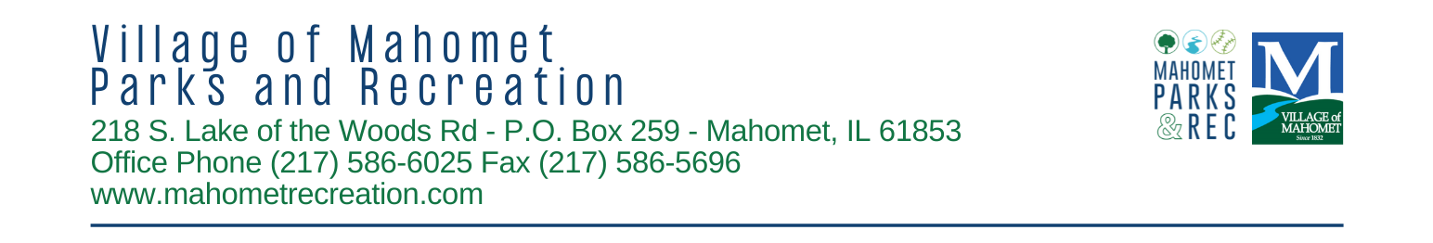

SPONSORSHIP FORM 2025
1. Contact Information
Sponsoring Agency:
Representative: |  |  |  |  |  |  |  |  |  |  |  |  |  |  | Title:
Address: |  |  |  |  |  |  |  |  |  |  |  | City: |  |  |  |  |  |  |  | Zip:
Phone: |  |  |  |  |  |  |  |  |  |  | Alt. Phone:
Email: |  |  |  |  |  |  |  |  |  |  | Website:
2. Sponsorship Level/Type
 | Youth Sports Leagues |  |  |  |  |  |  |  | Diamond $2500+ Platinum $1000+ Gold $500+ Silver $300+
 | Turkey Trot |  |  |  |  |  |  |  | Title $750 (SOLD - Fisher National Bank) Supporting $300
 | Egg Hunt |  |  |  |  |  |  |  | Title $750 (SOLD – Dominos) Supporting $300
 | Touch a Truck |  |  |  |  |  |  |  | Title $750 (SOLD - Bulldog Automotive) Supporting $300
 | Neighborhood Nights |  |  |  |  |  |  |  | Title $2000 (SOLD - Fisher National Bank) Supporting $500
 | Dad/Daughter  & Mom/Son Dances |  |  |  |  |  |  |  | Title $750 (SOLD - Twist & Shout Dance & Cheer) Supporting $300
 | Adult Leagues |  |  |  |  |  |  |  | Pickleball $1000 Volleyball $750 Softball $500
 | Movie Night |  |  |  |  |  |  |  | Title $750 Supporting $300
 | Middletown Tennis & Pickle Naming Rights |  |  |  |  |  |  |  | Court $2000/yr (5 yrs) Net $1000/yr (5 yrs)
 | Program Guide Ad |  |  |  |  |  |  |  | Full Page - $500 ½ Page - $300 ¼ Page - $200
 | Taylor Field Banner |  |  |  |  |  |  |  | 1 Banner - $650
 |  |  |  |  |  |  |  |  | TOTAL PAYMENT: $
Child(ren) you wish to Sponsor?  (No guarantee but we do our best to pair you with your request when possible) |  |  |  |  |  |  |  |  | Print Names here:
3. Signature
Please Sign: |  |  |  |  |  |  |  |  |  |  |  |  |  |  |  |  |  | Date:
For Office Use Only
Cash |  |  | Check |  |  |  | Logo |  |  |  |  |  |  |  |  |  |  |  | Entered on web
Online |  |  |  | Check # _______ |  |  |  |  |  | Date Received: |  |  |  |  |  |  |  |  | Thank you sent

Pay online @ www.mahometrecreation.com, click on programs or mail check along with form by December 15th to:
Mahomet Parks & Recreation
503 E. Main Street, Mahomet, IL 61853

